# 1 – Queenie the horse
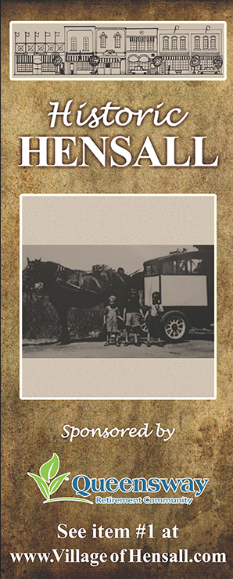

Hensall’s settlers first purchased milk from the dairy at Rodgerville and milk became available commercially when J. Malcolm began peddling milk produced by a small herd kept at his farm on London Road.
Milk sold for four to five cents a quart with customers supplying their own containers. Bottled milk became available at the turn of the century when Jim Patterson took over the business. When Patterson left the business, village cows pasturing along the roadside again became the only source of milk. Until a by-law forced cattle owners to engage a herdsman.
In 1923 Tom Sherritt established the first dairy. In 1927 Oliver Rowcliffe purchased the business and installed a pasteurization plant. Construction of the latest modernized dairy was completed by Lloyd Mousseau in 1959 after a tornado destroyed the original plant.
Queenie (the milk wagon’s horse) was well known as the Village babysitter. Many mothers sent their children to the front window to watch for Queenie and the milk wagon. Hours later they would still be looking out the window. Queenie and the milk wagon entertained many a village child in the mornings of bygone years. In 1969 the horse drawn milk wagon became a memory with the retirement of Queenie after 20 years of service. The replacement vans serviced the surrounding small towns (and in 1961 and 1976 respectively, Ron Mock purchased the Zurich and Exeter dairies) and then supplied the whole of south Huron.
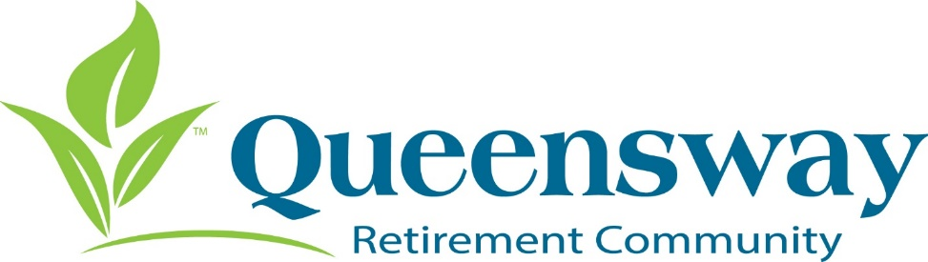
Sponsored by:

